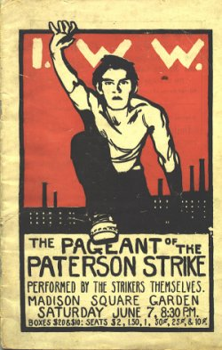
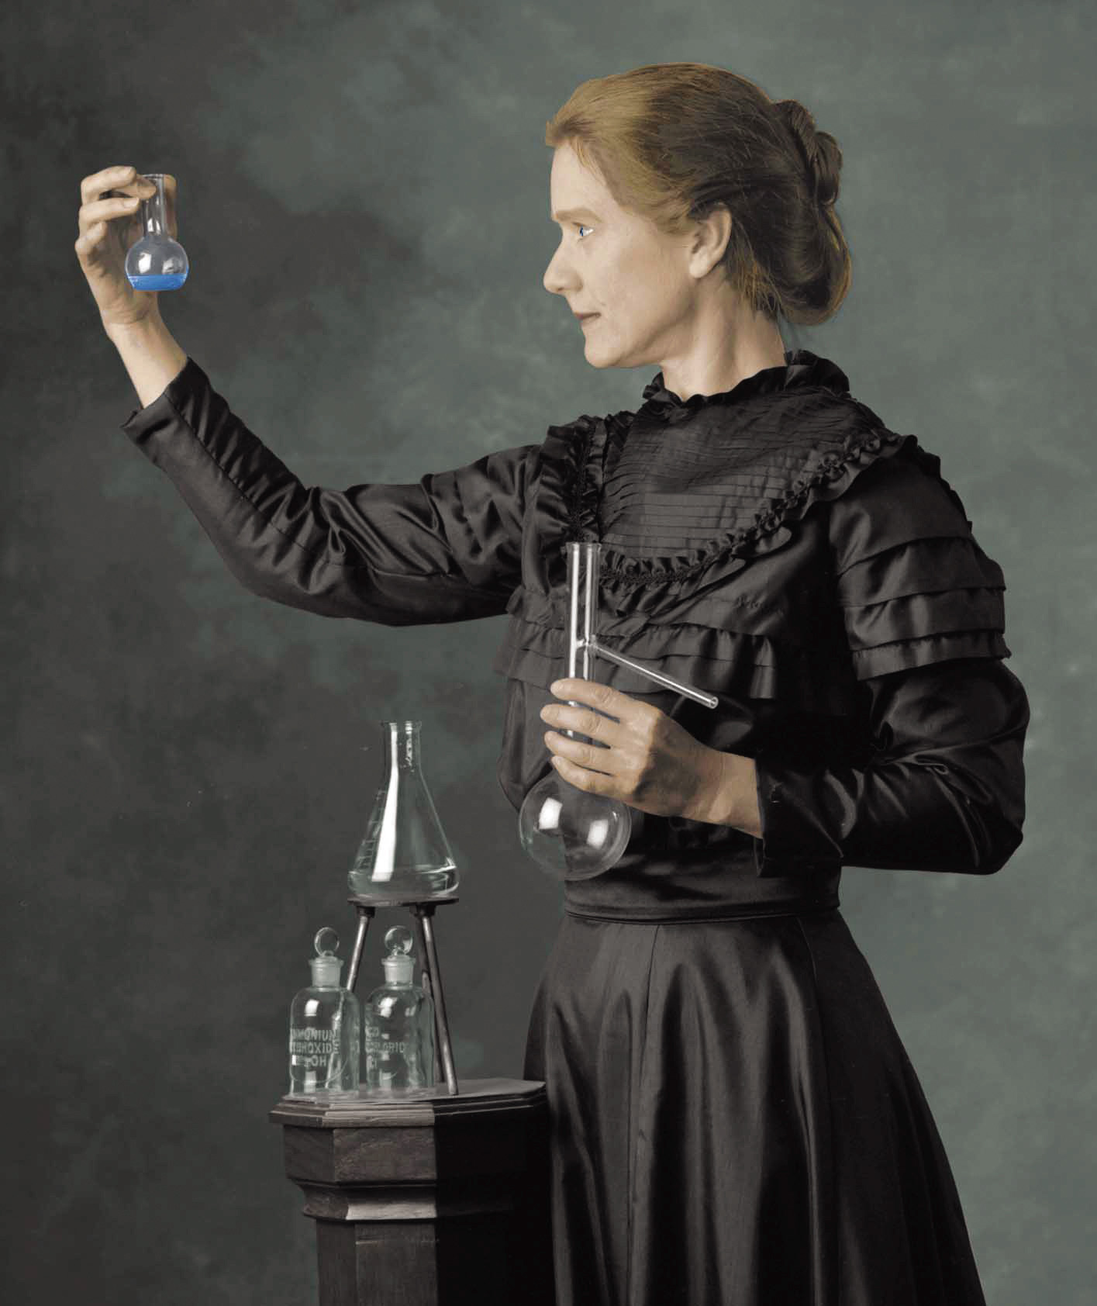
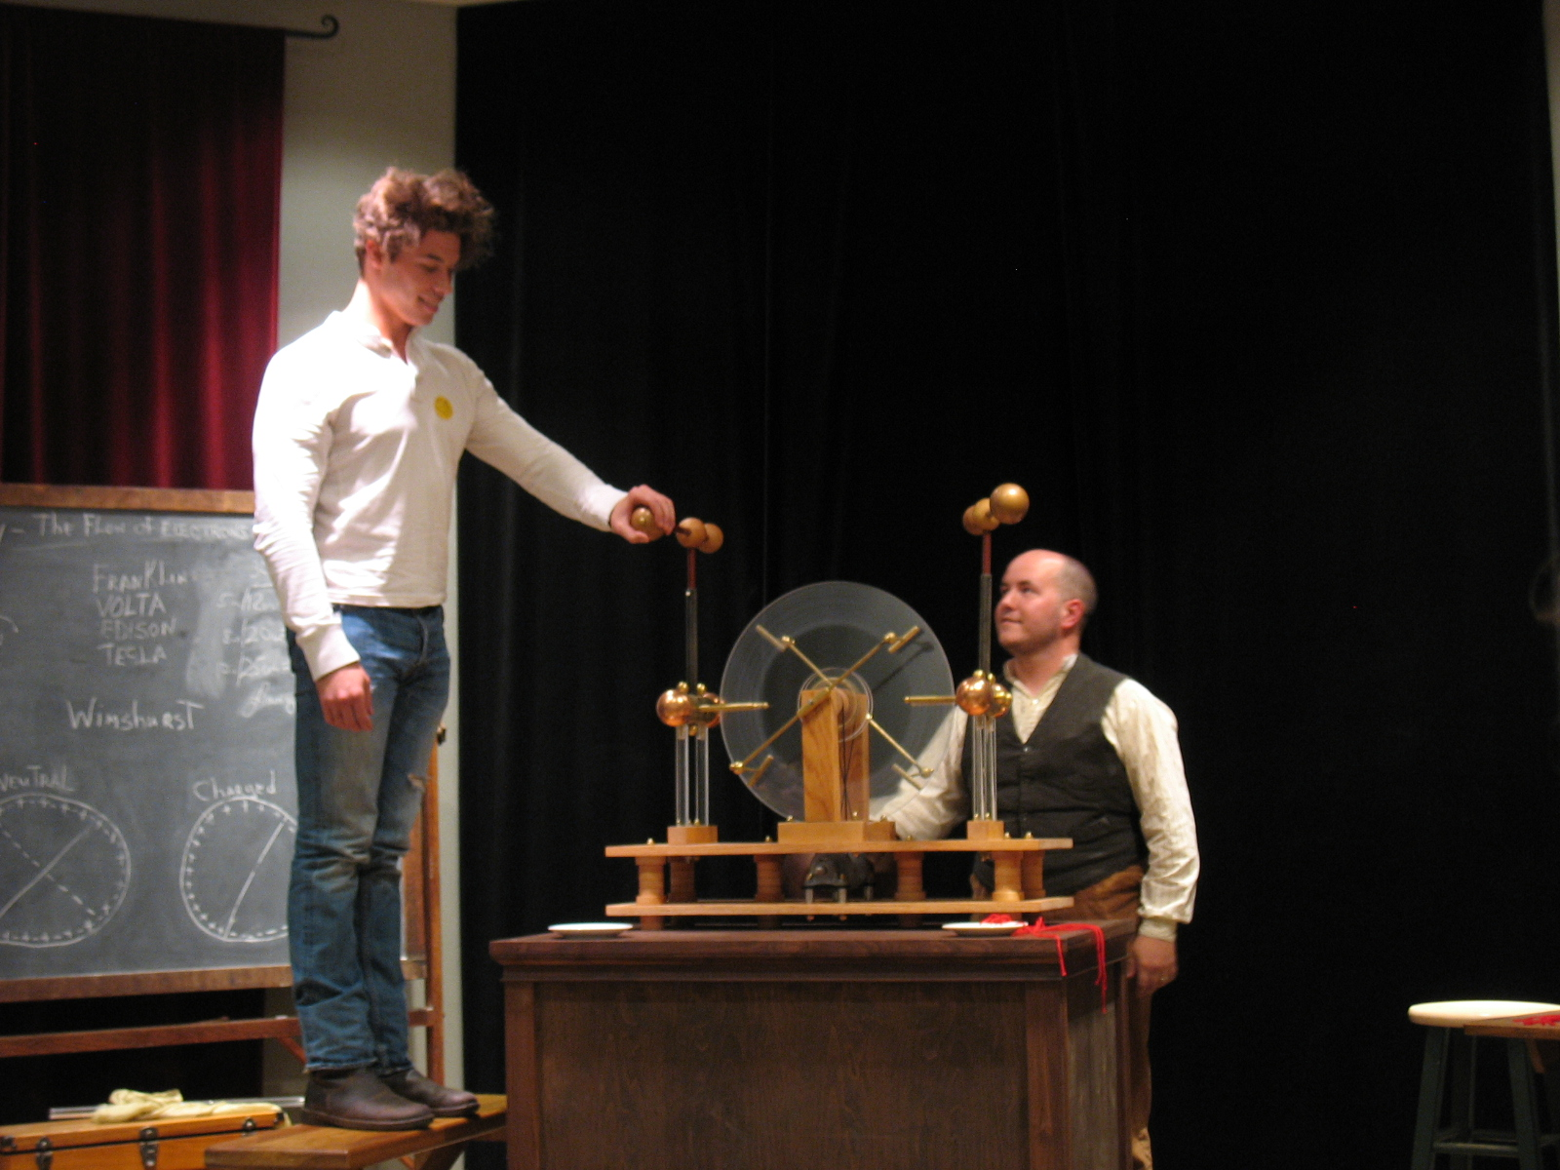
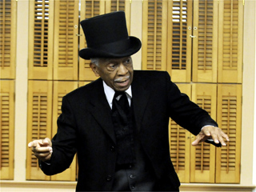
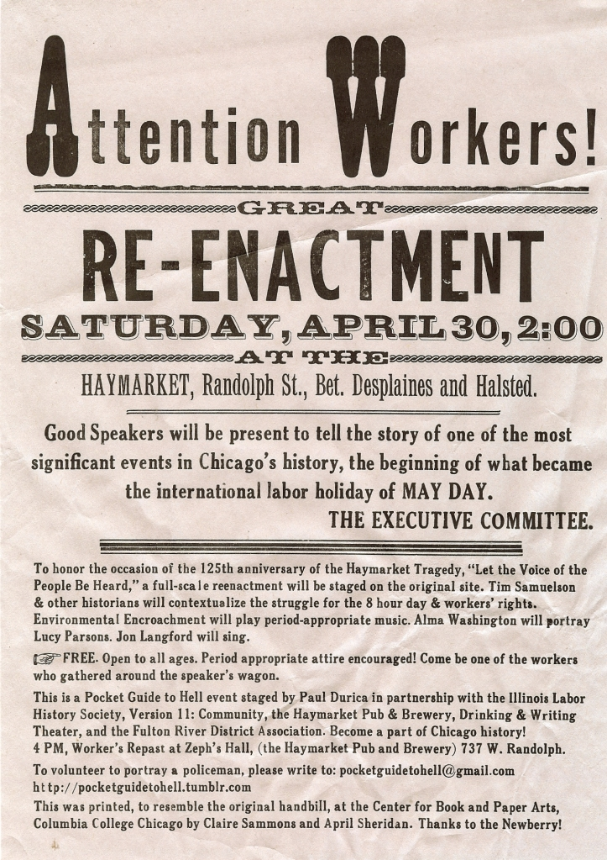
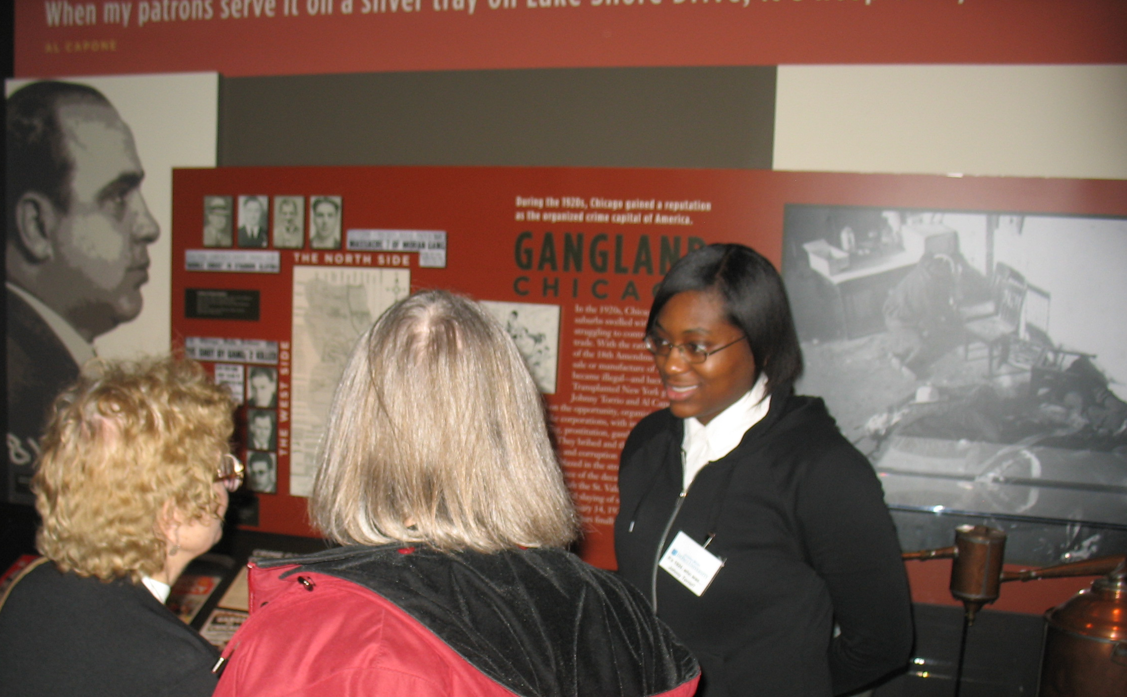
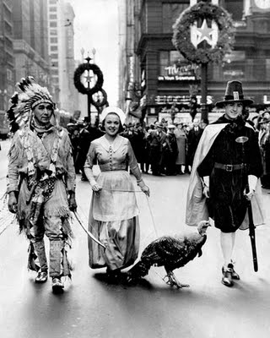
Interested upper division history AND non-history majors may enroll.

Non-history majors, write Dr. Tyson at atyson2@depaul.edu for more information (send her your student ID, email address, and full name).
We’ll learn about living history, war reenacting (and other types, too), museum theater, museum educational programming, and the art of live historical interpretation. While we’ll read classic and recent scholarly texts on the topics at hand, hands-on learning is at the heart of this class. If we enroll enough students we will also journey back in time to play a history game over the course of the quarter called “Greenwich Village 1913: Suffrage, Labor, the New Woman.” http://reacting.barnard.edu/greenwich-village-1913-suffrage-labor-and-new-woman I promise you, you have not experienced anything like this at DePaul before. For this game to run, we need several more students to enroll in the course, so sign up and spread the news so this history role-playing game can run!
In this class, you will take steps to compile a portfolio for use in future job searches. The portfolio will showcase your original historical research, which you’ll have put to use in designing museum educational programming that incorporates living historical interpretation.
We also may take a field trip or two.

  - Performing History
  - Learning History through Museum Theater, Living History, and Historical Performance (U.S. Geographical Focus)

Live some history; enroll in this course today!

Course Offering Wednesdays 6-9:15 PM

What’s this course about?

HST 389: Fall 2011
Prof. Amy M. Tyson

